Daily Participation Scale (Affective Domain 70%)
 | Effort | Behavior | Responsibility
5  (MVP) | I can & do:  - meet or exceed physical expectations  - utilize instructed techniques  - Maintain continuous movement and be engaged throughout the class. | I can & do:  - Stay on task.  - Listen and follow directions.  - Use positive comments & appropriate language.  - Cope well with success and failure. | I can & do:  - Change into appropriate PE attire.  - Arrive to class on time.  - Participate energetically and safely with respect of others abilities.
4  (All-Star) | I can & do:  - actively participate  - Display acceptable effort. | I can & do:  - Perform all of the above bullets except one. | I can & do:  - Change into appropriate PE attire.  - Perform 1 of the other two above bullets.
3  (Role Player) | I can & do:  - Display moderate activity and effort. | I can & do:  - Perform at least two of the above behaviors. | I can & do:  - Change into appropriate PE attire.  I do not:  - Get to class on time.  - Participate energetically and safely with respect of others abilities.
2 | I am:  - mostly inactive  - Displaying minimal effort. | I can & do:  - Perform at least one of the above behaviors. | I do not:  - Change into appropriate PE attire.  I can & do:  - Perform the other 2 bullets.
1 | I am:  - Displaying minimum movement and effort. | I need:  - To be consistently reminded to perform the above behaviors. | I do not:  - Change into appropriate PE attire.  I can & do:  - Perform at least 1 of the other 2 bullets.
0 | I am:  - displaying no movement and/or effort | I do not:  - Perform any of the above behaviors. | I do not:  - Participate in class.
Hornell Intermediate School Physical Education Guidelines

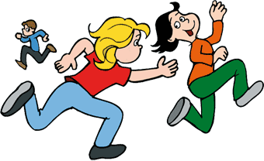

Cardiovascular Fitness Flexibility
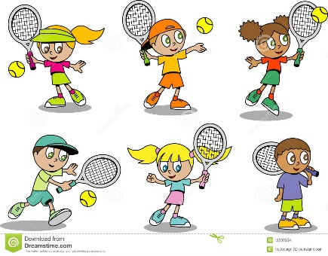
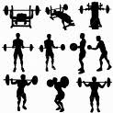

Muscular Strength Lifelong Fitness
And Endurance

Sport Education

